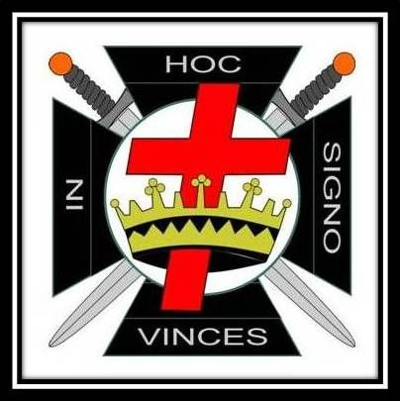
IN HOC SIGNO VINCES
TO ALL ILLUSTRIOUS KNIGHTS OF THE VALIANT AND MAGNANIMOUS ORDER OF THE TEMPLE
GREETINGs
THIS IS TO CERTIFY THAT SIR KNIGHT

Has received the Orders HEREOF and WAS DUBBED A KNIGHT AND CREATED A MEMBER OF COMMANDERY NO. UNDER THE JURISDICTION OF THE GRAND COMMANDERY, KNIGHTS TEMPLAR OF FLORIDA. ON THE DATE INSCRIBED BELOW AND AS SUCH IS ENTITLED TO ALL RIGHTS AND PRIVILEGES OF TEMPLARY AND TO BE RECEIVED WITH KNIGHTLY COURTESY AND HOSPITALITY BY HIS FELLOW SIR KNIGHTS WHEREVER DISPERSED.
IN TESTIMONY WHEREOF, WE HAVE HEREUNTO
SET OUR HANDS AND CAUSED THE SEAL OF THE
COMMANDERY TO BE AFFIXED, THIS DAY
OF IN THE YEAR OF OUR LORD.
AND OF THE ORDER .

_________________________ _______________________________
RECORDER EMINENT COMMANDER

